Lesson #3: Sensitive Information Disclosure

Part 1 — Goal and Vulnerability Summary
This lesson demonstrates Sensitive Information Disclosure in the DVSA-ORDER-ORDERS AWS Lambda function. The main affected component is the order retrieval API (POST /dvsa/order), backed by the get_orders.py Lambda handler. When a logged-in user visits the My Orders page, the API response includes an internal field — confirmationToken — that serves no functional purpose on the client side. This token is a backend value used for internal order confirmation processing and should never be sent to the browser. Exposing it violates the principle of data minimisation and unnecessarily increases the attack surface by delivering an internal server-side identifier in plaintext to every authenticated browser session. The security impact is information over-exposure: any user with basic browser knowledge can read these tokens directly from the Network tab in DevTools without any special tools or skills.

Part 2 — Why This Works / Root Cause
The vulnerability exists because the developer included all available DynamoDB item fields in the API response without filtering out internal-only attributes. In get_orders.py, the response object is constructed as:

item = {"order-id": i["orderId"], "date": i["paymentTS"],
"total": i["totalAmount"], "status": human_status[status],
"token": i["confirmationToken"]} # <-- should not be here

The confirmationToken is stored in DynamoDB for internal order confirmation purposes. Because no data-minimisation logic was applied before serialising the response, this field is sent to the client on every order fetch. The fix is to remove the token key from the response dictionary so that only the fields genuinely needed by the frontend are returned.

Part 3 — Environment and Setup

Item | Details
DVSA URL | http://dvsa-website-test-207791567927-us-east-1.s3-website.us-east-1.amazonaws.com/orders
Endpoint / Function | POST https://5h67jdgdg7.execute-api.us-east-1.amazonaws.com/dvsa/order
Lambda Function | DVSA-ORDER-ORDERS (get_orders.py)
Tools | Chrome DevTools (Network tab), AWS Lambda Console
User Context | Normal authenticated user — no admin privileges needed
AWS Region | us-east-1 (N. Virginia)

Part 4 — Reproduction Steps
- Open the DVSA web application and log in with a normal user account.
- Navigate to the My Orders page to trigger the order fetch API call.
- Open Chrome DevTools (F12) → click the Network tab → select Fetch/XHR filter → click Preserve log.
- Observe the POST request to /dvsa/order. Click that request in the Network tab.
- Click the Response tab on the right side of DevTools.
- The API returns a JSON array of orders. Each order object contains: order-id, date, total, status, and critically the token field (confirmationToken).
- Confirm that the token values (e.g. FsnZ9T2ERmG2, A7bvxw8eq3rn, zoUhrxwYButl) appear in the raw JSON response even though they serve no UI purpose.

Part 5 — Evidence and Proof

Figure 1 — DevTools Network Response showing token field BEFORE fix
The My Orders page is open with Chrome DevTools Network Response tab visible. The API response clearly shows the token field for each order with raw confirmationToken values exposed in plaintext. The values are also rendered visibly in the My Orders page under the Confirmation column.
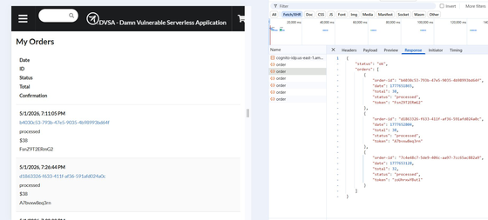
Figure 1: My Orders page — DevTools Network Response tab showing 'token' field with values FsnZ9T2ERmG2, A7bvxw8eq3rn, zoUhrxwYButl exposed in every order object

The raw JSON response captured from the Network tab:
{"status": "ok", "orders": [
{"order-id": "b4030c53-...", "date": 1777651865, "total": 38,
"status": "processed", "token": "FsnZ9T2ERmG2"},
{"order-id": "d1863326-...", "date": 1777652804, "total": 38,
"status": "processed", "token": "A7bvxw8eq3rn"},
{"order-id": "7c4e48c7-...", "date": 1777653128, "total": 32,
"status": "processed", "token": "zoUhrxwYButl"}
]}

Part 6 — Fix Strategy / Probable Mitigation
The fix belongs inside the get_orders.py Lambda handler within the DVSA-ORDER-ORDERS function. The required security improvement is data minimisation: the API response should include only the fields that the frontend actually needs — order-id, date, total, and status. The confirmationToken is an internal backend value and must not be serialised into the client-facing response. Removing the token key from both response dictionaries in get_orders.py directly addresses the root cause without affecting any other functionality.

Part 7 — Code / Config Changes
Location of fix:
- Lambda function: DVSA-ORDER-ORDERS
- File: get_orders.py — both loops where the item dict is constructed

Vulnerable code (before fix — commented out):
# VULNERABLE CODE (before fix) - token field exposed to client
# item = {"order-id": i["orderId"], "date": i["paymentTS"],
# "total": i["totalAmount"], "status": human_status[status],
# "token": i["confirmationToken"]}

Fixed code (after fix):
# FIX: removed "token" field - confirmationToken is internal only
item = {"order-id": i["orderId"], "date": i["paymentTS"],
"total": i["totalAmount"], "status": human_status[status]}

Figure 2 — Lambda code showing fix with vulnerable line commented
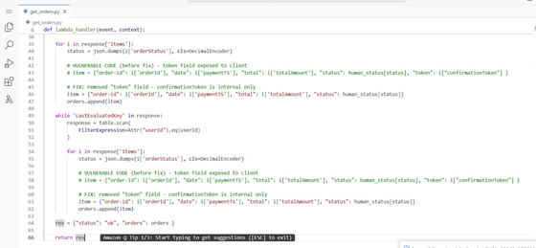
Figure 2: Lambda get_orders.py — vulnerable token line commented out and fixed version without token field deployed in both loops

Part 8 — Verification After Fix
After deploying the fix, the My Orders page was refreshed and the same POST /dvsa/order request was observed in DevTools.

Figure 3 — DevTools Network Response AFTER fix — token field absent
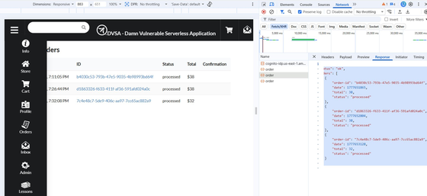
Figure 3: My Orders page after fix — DevTools Network Response shows order objects with only order-id, date, total, status. The token field is completely absent from all three orders.

Post-fix response:
{"status": "ok", "orders": [
{"order-id": "b4030c53-...", "date": 1777651865, "total": 38, "status": "processed"},
{"order-id": "d1863326-...", "date": 1777652804, "total": 38, "status": "processed"},
{"order-id": "7c4e48c7-...", "date": 1777653128, "total": 32, "status": "processed"}
]}

What changed: The token field is completely absent from all order objects. The My Orders page continues to load normally with all orders showing correct dates, amounts, and statuses. No functionality was broken.

Part 9 — Structured Operation and Security Analysis
9a. Intended Logic and Security Rule(s)
The intended logic of the My Orders workflow is: an authenticated user sends a POST request to /dvsa/order. The DVSA-ORDER-ORDERS Lambda function queries DynamoDB for all orders belonging to that user and returns a JSON array containing only display-relevant fields: order ID, date, total amount, and status. The confirmationToken is an internal backend field stored in DynamoDB for order-confirmation processing and should never leave the server.

- Security Rule 1: The API MUST NOT expose internal DynamoDB attributes that serve no client-side purpose.
- Security Rule 2: API responses MUST apply data minimisation — only fields required by the frontend should be serialised.

9b. Evidence Sources and Behavior Trace
- Sources: Chrome DevTools Network Response tab, AWS Lambda source code (get_orders.py), post-fix API response comparison.
- Normal: POST /dvsa/order returns only order-id, date, total, status. Token field absent.
- Exploit: POST /dvsa/order returns order-id, date, total, status AND token (FsnZ9T2ERmG2, A7bvxw8eq3rn, zoUhrxwYButl) visible in browser.
- Post-fix: POST /dvsa/order returns only order-id, date, total, status. Token completely absent.

9c. Deviation Analysis and Classification
The exploit deviates from Security Rule 1 and Rule 2. The API response included the confirmationToken field which is an internal DynamoDB attribute with no UI function. This is proven by the DevTools Network Response screenshot showing the token key with literal values in the JSON payload. Classification: Accidental misconfiguration — the developer included all available fields without intentionally designing an exploit, but omission of data-filtering logic resulted in over-exposure.

9d. Explainable Fix and Post-Fix Validation
Wrong assumption: all DynamoDB fields retrieved by the Lambda are safe to return to the client. Fix location: get_orders.py inside DVSA-ORDER-ORDERS Lambda. Change: removed 'token': i['confirmationToken'] from response dict in both loops, commented vulnerable lines, redeployed. Post-fix: token field absent from API response; all order data still returned correctly.

Standard Summary Tables

Table A — Structured Analysis Summary

Vulnerability | Intended Rule(s) | Artifacts Used | Normal Behavior Evidence | Exploit Behavior Evidence
Lesson #3: Sensitive Information Disclosure | Rule 1: API must not expose internal DynamoDB attributes with no client-side purpose. Rule 2: API responses must apply data minimisation. | Chrome DevTools Network Response tab, AWS Lambda source code (get_orders.py), post-fix API response comparison | POST /dvsa/order returns only order-id, date, total, status. No token field. My Orders page displays correctly. | POST /dvsa/order returns token field with raw confirmationToken values (FsnZ9T2ERmG2, A7bvxw8eq3rn, zoUhrxwYButl) visible in DevTools and rendered in Confirmation column.

Table B — Structured Analysis Summary

Vulnerability | Why This Is a Deviation | Deviation Class | Fix Applied (Where) | Post-Fix Verification | Optional Logging
Lesson #3: Sensitive Information Disclosure | API included confirmationToken in client response, violating Rule 1 and Rule 2. Internal backend token delivered in plaintext to every authenticated browser session. | Accidental misconfiguration | Removed 'token': i['confirmationToken'] from both response dicts in get_orders.py. Vulnerable lines commented. Fixed code deployed. | Post-fix DevTools shows no token field in any order. My Orders page loads normally with all order data intact. | Not applicable — no timing impact.

Part 10 — Takeaway / Lessons Learned
This vulnerability illustrates that sensitive information disclosure does not always involve dramatic attacks. Sometimes it is simply a matter of including one extra field in an API response that should not be there. In a serverless environment, Lambda functions often query DynamoDB and return results directly, making it easy for developers to accidentally expose internal fields. The general principle that prevents this is data minimisation: every API response should be explicitly constructed to include only the fields required by the consumer, rather than forwarding all available data from the backend store.

